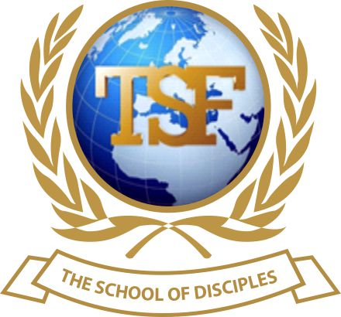
TSF SCHOOL OF DISCIPLES

CERTIFICATE IN CHRISTIAN DISCIPLESHIP

Assignment
Module 4.20 ~ The Final Conflict

NAME: _______________Isha Kargbo______________________

Please use your notes and general research to answer the following questions.
TSF School of Disciples
MODULES 4.20 Assignment

Name: ……………………………………................. Score: …………
MODULE 4.20: The Final Conflict

1) What is the Final Conflict? Name the three events preceding the final conflict? The final conflict will occur after the 1,000 years. Satan will be defeated and our lord and savior will be acknowledge as lord of all.
The three major events preceding the final conflict are as follow:

- Pretribulation
- Midtribulation
- Posttribulation

2) With the outpouring of the gift of Holy Spirit, it can be revealed to anointed man or woman of God the time of 'The Rapture'. TRUE / FALSE? (Support your answer with a Bible passage) FALSE In Matthew 24 Jesus clearly stated it that no man will know the exact time of the rapture. Everyone will be caught by surprise. (Matthew 24;36)

3) In Matthew 24:38 - 44; which period of time was our Lord Jesus Christ talking about? He was talking about his coming.

4) According to Daniel 9:24 - 27; how long will 'The Tribulation' last? According to Daniel 9:24-27, the tribulation will last for 42 Months or 1,260 days.

5) List the three things that will distinguish 'The Tribulation' time from all other times of trouble?
1 It will be world wide not just local. Revelations 3:10
2 The intensity of the trouble will be greater than ever before experienced which are described in Revelation 6,8-9 and 16.
3 The people will realize that the end of the world is near.{Revelation 6:16-17)

6) What is your understanding of the Millennium? The millennium is refer to the 1,000 years reign of Christ after the tribulation as mention on revelation 20:3, Zechariah 14:9

7) If the Final Conflict will decide the War; how did the war start and who is the enemy? According to Revelation 12:7-9. The war/grand conflict started in Heaven between rebel angels under lucifer and the loyal angels under Michael. So, Satan is the enemy.

Complete the following quotes and add the Bible passages:-

8i) And the devil that deceived them was cast into the lake of fire and brimstone, where the beast and the false prophet are, and shall be tormented day and night for ever and ever. (Revelation 20:10KJV)

ii) Having made known unto us the mystery of his will, according to his good pleasure which he hath purposed in himself:
10 That in the dispensation of the fulness of times he might gather together in one all things in Christ, both which are in heaven, and which are on earth; even in him: (Ephesians 1:9-10)

iii) Then to Him was given dominion and glory and a kingdom, That all peoples, nations, and languages should serve Him. His dominion is an everlasting dominion, Which shall not pass away, And His kingdom the one Which shall not be destroyed. (Daniel 7:14)

iv) But thanks be to God, which giveth us the victory through our Lord Jesus Christ. 1 Corinthians 15:57

Life Applications:
9) Study Matthew 24:45 - 51 what is the key message in this passage? The key message is for believers to be ready, be at our post and continue to do the work we are appointed to do, so when our master Jesus comes he will find us doing his work.

10) What does the story of the ten virgins teach us about the Final Conflict (Matthew 25:1 – 13) The story of the ten virgins is a reminder to be prepared for the unexpected second coming of our dear lord and savior Jesus Christ.

