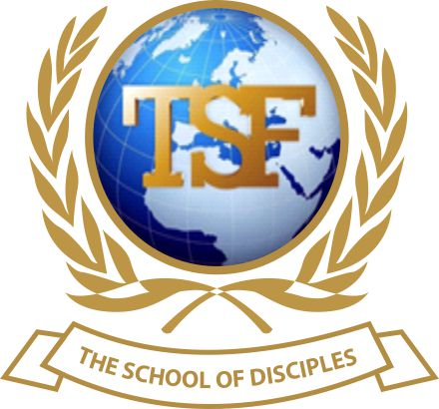
TSF SCHOOL OF DISCIPLES

CERTIFICATE IN CHRISTIAN DISCIPLESHIP

Assignment
Module 4.14 ~The Authority Of A Disciple - Power To Bind, Loose And Spoil

NAME: _____ISHA KARGBO

Please use your notes and general research to answer the following questions.
TSF School of Disciples
MODULES 4.14 Assignment

Name: ……………………………………................. Score: …………

MODULE 4.14: The Authority of a Disciple - Power to Bind, Loose and Spoil

1) What do you understand by the term to “Bind” being a metaphor?
In the biblical language to “bind” it means to “forbid” Satan from having access in God’s owns and to hinder his work against God’s children. (Mathew 16:19)

2) Why is binding an effective witnessing tool?
Binding is an effective witnessing tool that disciples of Jesus Christ should use when seeking for the salvation of someone. A disciple can bind the spirit (strong man) that has been blinding the eyes of that individual from receiving the gospel of Jesus Christ first and then minister salvation to that individual. (light) (Luke 11:21-22, Mark 3:27)

3) To “Bind” means to STOP the activities of Satan through the authority given by our Lord Jesus Christ, not by shouting I bind you Satan! Why?
Because the bible says that by strength shall no man prevail and victory come through Jesus Christ who has the ability to save, deliver and restore. (Romans 8:37) An example here is the sons of Scava, a Jewish chief in Acts 19: 13-15, who were using the name of Jesus with all their strength and might but, all to no avail, to the extent that the evil spirit even asked who they were. They were not saved. You can’t do the work of God by imitating others. You must be saved and rooted in the word of God to be able to bind/ stop the activities of Satan. (1 Samuel 2:9, Acts 19: 13-15)

4) With the Resurrection of Christ, Satan was conquered once and for all; why then is he still able to afflict believers?
In my opinion, it is because most believers don’t know their authority in Christ Jesus. They are in church but, at the same time busy pleasing the world. Trying to belong or fit in. Yes, Satan was conquered once and for all by our lord and saviour, but that doesn’t mean that a believer should keep on sinning. (Romans 6:1) A true believer can’t be influence by the enemy nor drag easily into the spirit of lust. Their focus is on the crown of glory that await them in heaven. (1 Corinthians 9:25)

5) As God’s battle-axe and the knowledge of Satan’s agenda to “ Kill, Steal and destroy” what do we do regarding Satan’ activities?

The first thing to do is to know your right and tools and get a full understanding about battle (who) you are fighting. The next step is to know where you belong and disassociate yourself from anything/ anyone that bears the mark Satan.

6) Power without authority is an abuse and authority without power is pointless! Study Acts 8:18-23; What does this passage teach us?
From these verses I understand that you can’t buy power because if you do you will abuse it as there is no authority behind it. As believers we have the authority through Christ to perform miracles and heal the sick. There is a higher authority that back us up to do sings and wonders.

7) Should believers pray for mountain to be removed OR we are to speak with the authority and power given to us by our Lord Jesus Christ and command that a mountain be removed? TRUE / FALSE (Support your answer with a Bible passage)
False, we are to speak with the authority and power given to us by our lord Jesus Christ.
According to Mark 11:22-23, faith and the spoken words are the requirement to move mountains. A believer can move any mountain if they believe the word of God and what they are saying/prophesying to themselves.

Complete the following quotes and add the Bible passages:-

8) And I will give you the keys of the kingdom of heaven, and whatever you bind on earth will be bound in heaven, and whatever you loose on earth will be loosed in heaven. (Mathew 16:19)

9) When a strong man, fully armed, guards his own place, his goods are in peace. But when a stronger than he comes upon him and overcomes him, he takes from him all his armor in which he trusted, and divides his spoils. Luke 11:21-22)
Life Applications:
10) A group of prayer champions in your Church are concerned that they are not as effective as they expect when interceding for members and their family. They have been praying on the basis of the power and authority given to disciples in Matthew 18:19 and Luke 10:19.
a) Explain to them what could be responsible for their lack of success.
Beloved, yes, you have authority in Christ Jesus but, there are conditions attached to that authority.
Few of the many things that could cause lack of success in prayers/warfare are unholiness, unforgiveness and bitterness
You can pray all you want, but if there is any form of bitterness in your heart for someone just know that there will be delay in your answer. That is why the bible admonished us to get rid of these thing as to have easy access to our authority. Ephesians 4:26, Mark 11:25, 2 Corinthians 7:1)

b) Explain in your own words what it means to PUT ON the full armour of God.

To put on the armour of God is to apply all of the gospel into your life so that you can receive all that God has in store for you. You put it on by believing what God has done for you through his son Jesus Christ. By doing so, you will be able to withstand spiritual pressures that you are going to face. (Ephesians 6:11)

11) Study Matthew 7:21 - 23 and explain the teachings of our Lord Jesus Christ in this Bible passage.
I think this passage refers to believers, especially those God has bestowed gifts on. You can prophesy all you want/know but, if you don’t do/prophesy the will of God then know that you are on your own. These people do miracles and heal the sick in Jesus name, they claim relationship with him, build huge churches and gather huge crowds, but they are never his. Because all these things they do are for themselves, fame and hunger for wealth.

